VIGENERE CIPHER

* PROBLEM STATEMENT
  + To encrypt a given plaintext to Vigenere cipher with key.
  + Decrypt the given Vigenere Cipher with key as well as without key.
* ENCRYPTION
  + The plain text and the key are passed as inputs to the Encryptor function.
  + Key is extended in order to match the length of the plain text.
  + The encryption of the original text is done using the Vigenere Square or Vigenere Table.

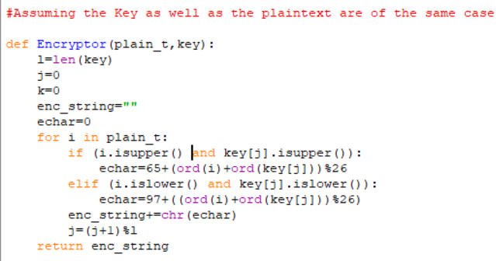

* DECRYPTION
  + Decryption is performed by going to the row in the table corresponding to the key, finding the position of the ciphertext letter in this row, and then using the column’s label as the plaintext.

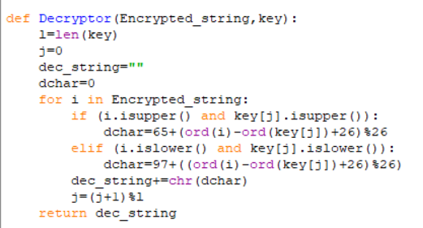

* Encryption Formula
  + The Plaintext(P) and the key(K) are added and modulo with 26.

Decrypted String=(P+K)%26

* Decryption Formula
  + Let encrypted string be E and key be k.

Plain Text=(E-K+26)%26

Hence the Encrypted and decrypted strings are generated.